**Confusion Matrix:**  
A confusion matrix is a summary of prediction results on a classification problem.  
The number of correct and incorrect predictions are summarized with count values and broken down by each class. This is the key to the confusion matrix.  
The confusion matrix shows the ways in which your classification model is confused when it makes predictions.  
It gives us insight not only into the errors being made by a classifier but more importantly the types of errors that are being made.

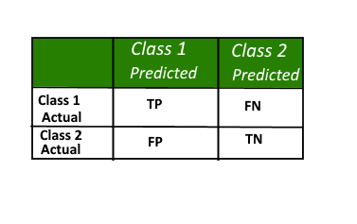

Here,  
• Class 1 : Positive  
• Class 2 : Negative

**Definition of the Terms:**  
• Positive (P) : Observation is positive (for example: is an apple).  
• Negative (N) : Observation is not positive (for example: is not an apple).  
• True Positive (TP) : Observation is positive, and is predicted to be positive.  
• False Negative (FN) : Observation is positive, but is predicted negative.  
• True Negative (TN) : Observation is negative, and is predicted to be negative.  
• False Positive (FP) : Observation is negative, but is predicted positive.

**Classification Rate/Accuracy:**  
Classification Rate or Accuracy is given by the relation:  
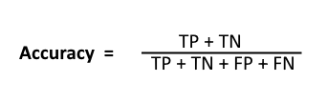

However, there are problems with accuracy. It assumes equal costs for both kinds of errors. A 99% accuracy can be excellent, good, mediocre, poor or terrible depending upon the problem.

**Recall:**  
Recall can be defined as the ratio of the total number of correctly classified positive examples divide to the total number of positive examples. High Recall indicates the class is correctly recognized (small number of FN).

Recall is given by the relation:  
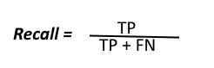  
**Precision:**  
To get the value of precision we divide the total number of correctly classified positive examples by the total number of predicted positive examples. High Precision indicates an example labeled as positive is indeed positive (small number of FP).  
Precision is given by the relation:  
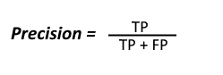

**High recall, low precision:**This means that most of the positive examples are correctly recognized (low FN) but there are a lot of false positives.

**Low recall, high precision:**This shows that we miss a lot of positive examples (high FN) but those we predict as positive are indeed positive (low FP)

**F-measure:**  
Since we have two measures (Precision and Recall) it helps to have a measurement that represents both of them. We calculate an F-measure which uses Harmonic Mean in place of Arithmetic Mean as it punishes the extreme values more.  
The F-Measure will always be nearer to the smaller value of Precision or Recall.  
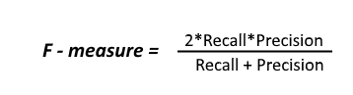

F1 scores are the harmonic means of precision and recall. Support columns in Classification report tell us about the actual counts of each class in test data.